Control Plane Connection Stack Architectural Description (phase 1)

Security Classification: | Restricted
Status: | DRAFT
Version: | 0.3
Team/Department : | Core Development/Networking Technologies
Author(s): | Petr Smrz
Owner(s): | Comms-Infras Technology Architect

Approver(s): | Comms-Infras Technology Architect | Distribution: | Networking Technologies Team

Contents
1 Introduction 3
1.1 Purpose and Scope 3
1.2 What is Bearer Mobility: Non-Technical Guide 3
1.3 Glossary of Terms 3
1.4 Philosophy behind the design and architectural changes 3
1.5 What is Bearer Mobility: Technical Version 4
2 Connection Stack Overview and Background 6
3 Connection Stack Architectural Changes 8
3.1 ESock Changes 8
3.2 Nifman Changes 8
3.3 ESockSvr Changes 8
3.4 BC proved future interface extensions 2
4 Main ESock APIs 3
4.1 Connections: CConnectionProviderBase, CConnectionFactoryContainer, CConnectionProviderFactoryBase 3
4.2 SubConnections: CsubConnectionProviderBase, CSubConnectionFactoryContainer, CSubConnectionProviderFactoryBase 5
4.3 Connection / Sub-connection Clients 6
4.4 Data monitoring CConnDataTransfer 7
4.5 Connection Settings CConnectionSettings 7
4.6 MConnectionEnumerateClients 8
4.7 MConnectionClientDesc 8
5 ECOM Plug-in APIs 9
5.1 IPCPR ECom Plug-in 9
5.2 IPSCPR ECom Plug-in 11
5.3 ShimCPR ECom plug-in 12
6 Classes interoperability description 16
6.1 Factories’ queries 16
7 Architectural Information 17
7.1 System Architectural Requirements 17
7.2 Binary Compatibility 17
7.3 Security 17
7.4 Future considerations 17
8 Further Information 18
8.1 People 18
8.2 References 18
8.3 Open Issues 18
8.4 Abbreviations 18
8.5 Document History 19

Introduction

Purpose and Scope
This document presents an overview of the changes made to ESock to support connection/sub-connection providers stack. The changes are mainly motivated by a growing need to support Bearer Mobility. These changes apply to the Symbian OS version 9.1 release. The main changes are described, along with the API’s they export and their relationship to each other within the wider comms-infras subsystem. The document provides a description of the first step towards control plane connection stack as outlined in [R4].

What is Bearer Mobility: Non-Technical Guide
Bearer Mobility is a step forward from multi-homing, which allows a handset to be connected to multiple types of network at the same time, but with no interaction between them: they are totally separate connections. For example, a single phone may be managing one or more voice calls, a GPRS link, a Bluetooth connection and a Wi-Fi connection simultaneously.
Bearer Mobility allows the phone to automatically pick the best ‘home’ to access a given type or item of data. Using potentially very advanced algorithms to consider the fastest or cheapest (the preference for which can be set by the user, or automatically by an individual application) bearing network available. Underneath the application level, connections are potentially dropped and initiated, however to the user and the active applications, their perception is that their connections have changed bearer transparently and automatically.
For example, a long web session during a train journey may therefore switch between a UMTS signal in a city, to a slower GPRS signal in the countryside, and perhaps to a Wi-Fi hotspot when pulling into a modern station. The factors which are taken into account should be chosen by the user, but from that point on the switching is automatic and occurs without loss of a connection, or the need to manually re-connect.

Glossary of Terms
For clarity, some terms used throughout this document are explained here. Some of them are particular to this work, others have meanings that can change with context and therefore need explanation.
- Provider is used in the sense of a class which provides either connections or subconnections, depending on its name.
- Connection is a collection of subconnections related to the particular connection preferences given by the layer (e.g. AP, NID). At the moment we have network layer and “shim” layer representing a link and talking directly to NIFMAN.. Connection can be viewed as a control side of a subconnection
- Subconnection represents a control side of a data channel(s). It allows for data monitoring and QoS settings
- Factories represent a concept of creating, enumerating, and querying providers
- Layering has been partially implemented in this version. Several methods are present which imply that layering has been completed but these are hooks for a future version.
- Connection Stack a stack of connection’s/sub-connection’s providers one on top of the other. The top of the stack, ending by CConnection/CSubConnection instances, represents the destination network configuration
- Next layer represents a bearer for the current layer that is accessed via the layer access point represented by connection preferences for the particular layer.
- Container in this context is almost always used to refer to a collection of factory classes. Such containers can therefore be used to gain access to factories, and provide many useful methods for managing them.

Philosophy behind the design and architectural changes
The main drivers behind the changes are the following:
- Allow third parties to develop their own address family based connection providers in a similar fashion as protocol providers
- Introduce a “vertical” responsibilities split: N/A boxes in the following table has not been defined as yet and are waiting for future development
Data Plane | Control Plane |  | Management Plane
Data | Data Control | Connection Control | Selection | Selection Control
RSocket | RSubConnection | RConnection | N/A | N/A
CSocket | CSubConnection | CConnection | Factories | N/A
CControlledServiceProvider | CSubConnectionProviderBase | CConnectionProviderBase | CConnectionProviderFactoryBase | N/A
Table 1-1 Vertical responsibilities split
- Introduce horizontal layering so that connections/sub-connections providers can be arbitrarily stacked one on top of the other creating a control plane stack mirroring the external network configuration. The very top layer represents the destination point configuration (e.g. VPN, IPSec configuration, destination network ID,…) The layers below represent the control side “hops” as to how what access points to use and how to configure them to actually reach the destination configuration.

What is Bearer Mobility: Technical Version
There are a number of infrastructure and low-level networking pre-requisites to enable true bearer mobility. This section ignores those tasks in the Bearer Mobility Proposal [R1] which relate to fixing inconsistencies in previous release of Symbian OS, and concentrate on just those tasks which enable control plane layers and allow us to move towards the “true” BM capability. In brief, these are:-
- Local IP resolution As many networks use a local IP address structure, it is entirely possible for totally unrelated and distinct networks to supply the handset with an identical IP address. The Symbian solution is to append a colon-plus-string namespace identifier to an IP address. Thus the duplicated local IP 100.3.67.126 becomes 100.3.67.126:gprs and 100.3.67.126:symbianintra and the phone can distinguish between the two networks.
- New layer between NIFMAN and ESOCK The support prior to 9.1 has been a direct 1-1 link between NIFMAN and ESOCK to support multi-homing. With the new Bearer Mobility support, it is necessary to break this link, insert a new network connection layer with its own API, and thereby make this link 1-many. In future it is anticipated that further optimisation will lead to the provision of a true ‘mobility server’ in its place.
- Removal of CInterface/CSubInterface/CSubConnection These classes and all associated concepts have been completely removed replaced by a new ‘shim’ control layer that effectively represents the link. This has caused significant knock-on changes to the rest of the ESock component, and these changes form a large portion of this document. CSubConnection has become a server side of RSubConnection.
- Removal of CSocket – CConnection dependency The CSocket owns CControlledServProviderShim instance as oppose to CServProviderBase. CControlledServProviderShim maintains a sub-connection provider instance representing a control side of a socket’s data channel so that the link CSocket – CConnection has become redundant.
- ECom Plug-ins ESOCK exposes interfaces implemented by ECom plug-ins. These are:
  - Connection related classes CConnectionProviderFactoryBase, CConnectionProviderBase plus client interfaces MConnectionControlClient and MConnectionDataClient.
  - Sub-connection related classes CSubConnectionProviderFactoryBase, CSubConnectionProviderBase plus client interfaces MSubConnectionControlClient and MSubConnectionDataClient.
Each plug-in must implement CConnectionProviderFactoryBase or CSubConnectionProviderFactoryBase interface. The implemented provider must support client interface to support layering unless it’s a provider meant for the very bottom layer only. Sub-Connections providers must implement MConnectionDataClient interface to allow for “horizontal” binding. In general the vertical binding creates the provider’s stack and is based on control clients (MConnectionControlClient / MSubConnectionControlClient). The horizontal binding converges towards data plane and is based on data clients (MConnectionControlClient / MSubConnectionControlClient).
It is covered in more detail in sections 4 and 5.
See the figure below for the high level element’s layout. The factories interactions are not shown since the factories interact with all connection elements apart from NIFMAN layer. The picture shows IP protocol only since no other protocols provide their own providers as yet effectively rendering the IP providers as implicit ones. The shim layer providers have to be always present to interact with NIFMAN and provide connection management link layer functionality. The colour legend in the applies to the all class diagrams thorough the document.
IPCPR + Selector

Comms Factories
CHostResolver
RHostResolver
CSubConnection
RSubConnection
Nifman SubConn + ShimCPR + Selector
CConnection
Colour Legend:
New - Temporary

New

Modified
omponentsaneselection is done ent of bearer details.
mented by the licensee depending on licensee specific requirementselection is done ent of bearer details.
mented by the licensee depending on licensee specific requirement
Existing
Network layer
Shim/Link layer
NIFMAN
AGT
NETCON
NIF
NIFMAN – current bottom of the connection stack
SubConnShim
Connection
Provider
Selection

Connection Provider
Selection

RSocket
RConnection
ESOCK Client

ESOCK – top of the connection stack
CSocket
CControlledServProvider

IPSCPR
TCPIP.PRT
QoS
Framework

GuQos Plugin

Figure 1-1 High Level Block Diagram

Connection Stack Overview and Background
The following top-level Rose model shows how existing packages have changed from the previous version of ESock. Boxes in bright yellow are changed, and red ones are completely removed. Pale yellow boxes are shown only so that the new relationships can be drawn: they remain unchanged.
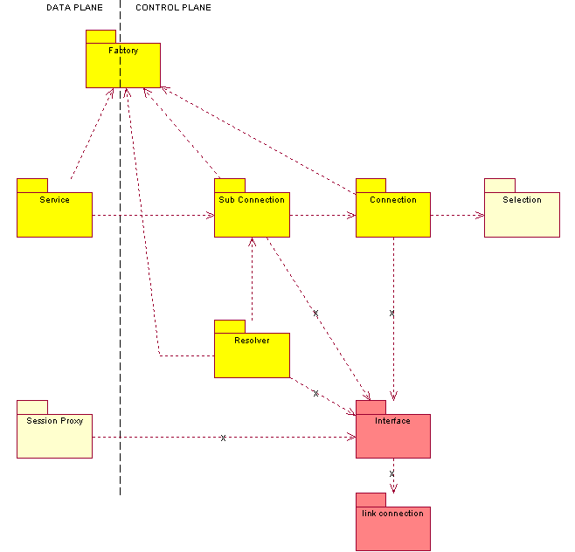
Fig. 2.1
There are also a number of completely new classes and relationships which are covered in section 4. The bearer mobility support for Symbian OS 9.1 has changed the following comms-infras components:-
- comms-infras/esock – Socket Server
- comms-infras/nifman – Network Interface Manager
- comms-infras/commsfw – Comms framework
- comms-infras/rootserver – Manager for Comms servers and provider modules
These changes to ESock and Nifman are described in section 3. The other changes are very minor and are covered briefly. In addition, several new ECom plug-ins have been created:-
- networking/ConnProv/ipcpr
- networking/ConnProv/shimcpr
- networking/SubConnProv/ipscpr
These are covered separately in section 5. The following diagram tries to capture the changes from a component perspective.
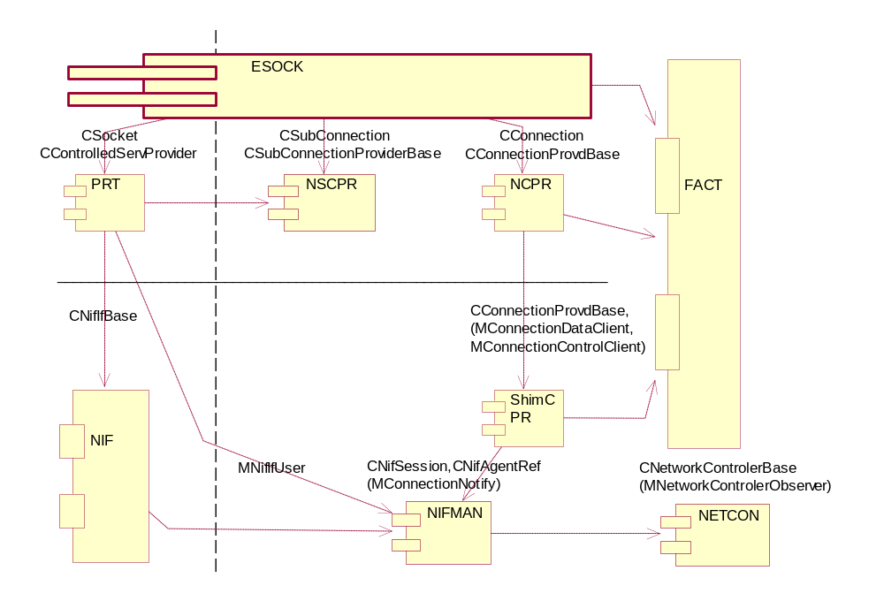
Figure 2-2 Component View

Connection Stack Architectural Changes

ESock Changes
The following ESock components have been changed. Most are very small changes, a minimal amount to ensure the old components still build with the BM changes. The SSock component has been radically changed and is dealt with in detail in section 4.
- comms-infras/esock/csock/cs_subconn.cpp, rconnection.cpp, sockmes.h (minor changes)

Nifman Changes
These are minimal and restricted to the file IF_API.CPP. Apart from including ss_sock.h and es_prov.h, there is a slight change to Nif::SetSocketState to account for the fact that the means of getting a pointer to the provider has changed. Another minor algorithmic change is in the function is CNifSession::AttachToConnectionL and CNifAgentRef::LinkLayerUp(). There are no further algorithmic changes.

ESockSvr Changes
ESOCK server is the most affected component since virtually whole connection control plane has been changed the following table lists the changes from the main impacted classes’ angle.

Removed | Modified | New

Server side of the client ‘R’ interface

CInterface | CSocket
CSubInterface | CHostResolver
CSubConnection | CConnection
 | CSubConnection2 became CSubConnection
Factory classes
CFactoryObject | CCommsFactoryContainer | XFactoryObject
 | CCommsFactoryBase
 | CControlledServProvider
 | CControlledServProviderShim
 | CSubConnectionFactoryContainer | CConnectionFactoryContainer
 | CSubConnectionProviderFactoryBase | CConnectionProviderFactoryBase
 | CSubConnectionProviderBase | CConnectionProviderBase
 | MSubConnectionClient | MConnectionClient
 | MSubConnectionDataClient | MConnectionDataClient
 |  | MConnectionControlClient
Provider classes, connection settings and data monitoring
 |  | CConnectionSettings
 |  | CConnDataTransfer
 |  | MConnDataTransferNotify
Removed | Modified | New
Factories, selection notifications
 |  | MProviderSelector
 |  | ISelectionNotify
 |  | IConnectionFactoryNotify
Esock MT classes
 | CPlayer | XSessionProxyEntry
 | CSockSessionProxy

Table 3-2 Summary of the main impacted classes
Detailed description of the classes follows in the section 4.

BC proved future interface extensions
All new provider classes implementation hides pure virtual function behind no-virtual exported counterparts delegating calls to the virtuals. All provider instances are registered by factories that keep a provider context structure. In case a new function(s) needs to be added only the non-virtual export is added and exported so that the existing providers don’t have to be touched a new provider on the other hand can indicate a support for the new function(s) by version in the provider context owned by the provider factory. That way the base class function can determine whether to call the new virtual or not.
The provider clients’ interfaces provide a function to fetch a custom interface instance based on the interface type id so that new client calls can be done this way and/or third parties developing their providers can find a particular interface they are looking for or figure out who their anonymous clients actually are. The function MConnectionControlClient::CtlType() could be of some help related to the last.

Main ESock APIs
This section explains changes to existing classes in brief, and concentrates mainly on those new classes introduced as part of the BM support.
The following table summarises the main API changes. Those listed as ‘minor’ in section 4.5 are not described in the table.
API Name | Broad Purpose
CConnectionProviderBase | Base class that all connection providers must derive from. In practice such derived classes will be ECom plug-ins such as IPCPR (see section 5).
CSubConnectionProviderBase | Base class that all subconnection providers must derive from. In practice such derived classes will be ECom plug-ins such as IPSCPR (see section 5).
CConnectionProviderFactoryBase | The factory for connection providers. This base class is currently implemented by the shim layer CConnectionProviderFactoryShim.
CConnectionFactoryContainer | The connection factory container is an implementation of the existing CCommsFactoryContainer.
CSubConnectionFactoryContainer | This is in fact an existing class, however substantial changes have been made. It implements CCommsFactoryContainer also.
MConnectionClient | A new base class connection clients need to implement.
MConnectionControlClient | This provides an interface which connection provider control clients need to implement
MConnectionDataClient | This provides an interface which connection provider data clients need to implement
MSubConnectionClient | A base class connection clients need to implement.
MSubConnectionControlClient | This provides an interface which sub-connection provider control clients need to implement
MCSubonnectionDataClient | This provides an interface which sub-connection provider data clients need to implement
Table 4-3 Main ESock classes

Connections: CConnectionProviderBase, CConnectionFactoryContainer, CConnectionProviderFactoryBase
This gives an indication of the main methods and their uses, plus less obvious information and subtleties. It is important, however, to remember that these, except CConnectionFactoryContainer, are base classes, and in many cases the implementation of a method at this level is simply to pass a request on to the implementing class. The following is a description of the public methods only. See the section for the description of the remaining methods.

CConnectinFactoryContainer methods
The following methods are mostly doing FindFactory of a given address family (factory id) plus call of a desired function on the found factory.
- FindProvider() looks up a provider of a given address family based on a query object
- FindOrCreateProviderL()looks up or creates if not found a provider of a given address family based on a query object
- CreateProviderL()creates a provider of a given address family
- SelectProvider()selects a provider of a given address family based on preferences. The selected provider is passed back via ISelectionNotify interface.
- SelectNextLayerProvider()selects a provider that is used as a bearer for the given address family based on preferences. The selected provider is passed back via ISelectionNotify interface.
- RegisterNotifierL() registers IConnectionFactoryNotify interface with a factory for the given address family
- FindFactory() finds a factory based on the address family
- Factory() returns a factory based on the index

CConnectionProviderFactoryBase methods
The following functions are working with a set of providers for the particular address family
- FindProvider() looks up a provider a query object
- FindOrCreateProviderL()looks up or creates if not found a provider based on a query object
- CreateProviderL()creates a provider
- SelectProvider()selects a provider based on preferences. The selected provider is passed back via ISelectionNotify interface.
- SelectNextLayerProvider()selects a provider that is used as a bearer for the “this” address family based on preferences. The selected provider is passed back via ISelectionNotify interface.
- RegisterNotifierL() registers IConnectionFactoryNotify interface with the factory
- DeRegisterNotifier()deregisters previously registered IConnectionFactoryNotify interface.
- EnumerateConnectionsL() enumerates existing connections providers

CConnectionProviderBase methods
- StartL() Exactly what is started here is determined by the class which derives from this. Not implemented as yet since the connection is started upon selection by NIFMAN
- Stop() stops the connection
- NextLayer() Ask our own connection to give itself to the next layer.
- JoinNextLayerL() the provider is asked to join given next layer
- ConnectionInfo()/ SetConnectionInfo() are getter/setter methods which return/take a descriptor which is mapped to the connection information.
- JoinL() is overloaded to allow joins on both data clients and control clients.
- Leave() is overloaded to allow leaving on both data clients and control clients.
- ProgressL() simply allows progress queries to be made.
- LastProgressError() returns the most recent error code.
- RequestServiceChangeNotificationL() and CancelServiceChangeNotification() notification when the underlying service for the connection changes.
- ControlL() takes an option level and name and passes the request on.
- AllSubConnectionNotificationEnable()/CancelAllSubConnectionNotification()
- SendIoctlMessageL()/SendCancelIoctl() passes/cancels the request for an ioctl command down to the next layer.
- passes the request to cancel an ioctl command down to the next layer.
- CanDoSubConnection() is currently a dummy that always returns ETrue.
- EnumerateSubConnectionsL() returns the number of subconnections only, no further information.
- ConnectionControlActivityL() requests a particular action which corresponds to one of the values of TControlActivity which can be any of EConnJoin, EConnLeave, EAttachNormal, EAttachMonitor, or ESetUsageProfile.
- SettingsAccessL() provides straightforward access to the class CconnectionSettings (see 4.5).
- DataClient() provides an access to the data clients using an integer index.
- ControlClient() provides an access to the control clients using an integer index.

SubConnections: CsubConnectionProviderBase, CSubConnectionFactoryContainer, CSubConnectionProviderFactoryBase
Following the connection logic all classes except CSubConnectionFactoryContainer are to be implemented by sub-connection(s) provider(s) plug-in(s). Sub-connections have traditionally been confused by the existence of the classes CSubConnection2 and CSubConnection. Steps have been taken to turn CSubConnection2 into CSubConnection and move the original CSubConnection to the shim level to become CSubConnectionLinkShimClient.. The shim client class is there to accommodate RConnection calls directed to subconnection The RConnection subconnection related calls based on the sub-connection Id need to be removed in the near future however.

CConnectinFactoryContainer methods
The following methods are mostly doing FindFactory of a given address family (factory id) plus call of a desired function on the found factory.
- FindProvider() looks up a provider of a given address family based on a query object
- FindOrCreateProviderL()looks up or creates if not found a provider of a given address family based on a query object
- FindFactory() finds a factory based on the address family

CSubConnectionProviderFactoryBase methods
The following functions are working with a set of providers for the particular address family
- FindProvider() looks up a provider a query object
- FindOrCreateProviderL()looks up or creates if not found a provider based on a query object
- CreateProviderL()creates a provider
- GetNextLayerProviderL() returns the bearer(next) layer sub-connection for a protocol family represented by “this” factory.

CSubConnectionProviderBase methods
- ControlClientsPresent() returns the number of MConnectionControlClient objects managed by this subconnection.
- DataClientsPresent() returns the number of MConnectionDataClient objects managed by this subconnection.
- ConnectionProvider() returns the “parent” connection provider the sub-connection provider is associated with (horizontal binding)
- JoinL() is overloaded to allow joins on both data clients and control clients. For data clients it is an asynchronous call, it completes via MSubConnectionDataClient::JoinComplete/JoinFailed once the data client has been routed (acquired source & destination address info).
- Leave() is overloaded to allow leaving on both data clients and control clients. For data clients it is an asynchronous call, it completes via MSubConnectionDataClient::LeaveComplete. On the LeaveComplete call the client should call FinalLeave to remove itself from the sub-connection provider data clients’ array.
- FinalLeave() takes a data Client requesting to be removed immediately from this sub-connection provider.
- SourceAddressUpdate() is called when the source address of a data client has been updated. It takes a reference to the data client that has a new source address and the new address.
- DestinationAddressUpdate() is called when the destination address of a data client has been updated. Similar usage to SourceAddressUpdate().
- DataClientRouted()The data client has found a route and now has all its address information defined. Takes a data client, source and destination addresses plus an Access Point.
- Control() is a generic control function, used to provide bespoke control of a specific sub-connection provider.
- SetParametersL() sets the sub-connection channel parameters. At the moment used for QoS & QoS policies only.
- StartL() Exactly what is started here is determined by the class which derives from this. Not implemented as yet see 4.1.3 StartL method
- Stop() Stops the sub connection
- SelfConnectionDataClient() returns a pointer to self of type MConnectionDataClient.
- NextLayer() returns the “this” sub-connection provider bearer (next) layer.
- DataTransferL() returns a CConnDataTransfer (see 4.4) based class to monitor data flow over the particular sub-connection

Connection / Sub-connection Clients
These are abstract classes defining interfaces for horizontal & vertical binding. In general the vertical binding creates the provider’s stack and is based on control clients (MConnectionControlClient / MSubConnectionControlClient). The horizontal binding converges towards data plane and is based on data clients (MconnectionDataClient / MSubConnectionDataClient).

MConnectionClient
The base class for connection data & control client interfaces
- ConnectionGoingDown() called from connection provider destructor to advise all clients that the provider is about to disappear.
- ConnectionError() advises all clients of a connection error.
- FetchInterfaceInstanceL() allows providers to fetch an arbitrary interface instance based on the interface type id.

MConnectionControlClient
Control client represents the upper (control) layer from the provider point of view.
- ProgressNotification() conveys the progress notifications up the stack
- ServiceChangeNotification()conveys the service change notifications up the stack
- SubConnectionEvent()conveys the sub-connection event up the stack
- LayerUp() signals the layer the client has joined is up
- CtlType() determines the client type (ENormal, EMonitor, ESession) affects the idle timers

MConnectionDataClient
Data client represents the data side of the provider. Usual data client in the connection provider case is a data client one way or the other related to a sub-connection channel.
- Notify() notifications from connection provider
- AttachToNext() advise from connection provider to attach to the bearer (next) sub-connection provider layer.

Data monitoring CConnDataTransfer
The class provides an abstraction for data monitoring. An instance of the class can be obtained via CSubConnectionProviderBase::DataTransferL() method. A client wishing to monitor data flow needs to implement MConnDataTransferNotify interface and register an instance with the CConnDataTransfer instance.

CConnDataTransfer
- DataTransferred() called by client to request data transferred notification
- DataTransferredCancel() called by client to cancel data transferred notification
- DataSentNotificationRequest() called by client to request data sent notification
- DataSentNotificationCancel() called by client to cancel data sent notification
- DataReceivedNotificationRequest() called by client to request data received notification
- DataReceivedNotificationCancel() called by client to cancel data received notification
- RegisterClientL() registers MConnDataTransferNotify client to send the notifications to
- DeRegisterClient() deregisters MConnDataTransferNotify client

MConnDataTransferNotify
- NotifyDataTransferred() data transferred notification up-call
- NotifyDataSent() data sent notification up-call
- NotifyDataReceived() data received notification up-call

Connection Settings CConnectionSettings
CConnectionSettings is a very simple class providing access to connection provider settings. Each setting is described by the string having a “path-like” format. The instance of the class can be obtained via CConnectonProviderBase::SettingsAccessL() call.
- GetBoolSettingL() retrieves a TBool value
- GetDes16SettingL() retrieves a TDes16 value of the know max length
- GetDes8SettingL() retrieves a TDes8 value of the know max length
- GetIntSettingL() retrieves a TInt value
- GetLongDesSettingLC() retrieves a HBufC value of beforehand unknown max length

MConnectionEnumerateClients
The MConnectionEnumerateClients is a custom interface having a type id equal to STypeId(KConnectionClientExtUid,EConnectionEnumerateClients) meaning that when a data client supports it can be obtained by MConnectionClient/MSubConnectionClient::FetchInterfaceInstanceL().
- EnumerateClientsL() enumerates clients of the particular client. E.g. allows for traversing through link of providers and their clients.

MConnectionClientDesc
It is another custom interface having a type id equal to STypeId(KConnectionClientExtUid, EConnectionClientDesc) meaning that when a data client supports it can be obtained by MConnectionClient/MSubConnectionClient::FetchInterfaceInstanceL().
- FetchOwnerInfo() retrieves a specialised info of the client supporting that interface. Works in conjunction with MConnectionEnumerateClients (4.6) interface.

ECOM Plug-in APIs
The concrete connection & sub-connection providers’ implementations are written as ECOM plug-ins. There are four ECom plug-ins here designed and written as a part of BM work. These are divided into two: the connection provider plug-in which comprises the IP Connection Provider (IPCPR) and the connection provider shim (SHIMCPR). The sub-connection provider (SCP) plug-in is similarly split into IPSCPR and SHIMSCPR.

IPCPR ECom Plug-in
This section provides a useful summary of the IP Connection Provider (IPCPR) ECom plugin. It is not an exhaustive user or developer manual but should provide enough basic information to convey an understanding of the plug-in design and use.
The methods and interfaces exposed in this plug-in allow third parties to implement advanced bearer mobility algorithms. The plug-in builds on a series of layers which progressively build this capability into ESOCK.

IP Connection Provider (CIPNetworkConnectionProvider)
This class is based on CConnectionProviderBase and implements MConnectionControlClient. The main purpose of the current implementation is to manipulate idle timers.

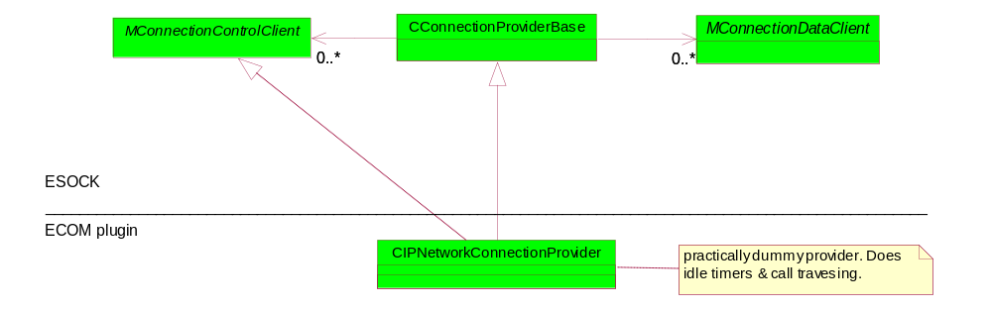
Figure 5-3 IPCPR connection provider class layout
Section 5.1.1 covers the main connection provider class and its many methods. Section 5.1.2 describes the factory which offers various synchronous and asynchronous factory methods to access, create and select providers.

IP Connection Provider Factory (CIPNetworkProviderFactory)
The factory class is based on CconnectionProviderFactoryBase. It creates CIPNetworkConnectionProvider and performs a very simple selection with help of CIPConnectionSelector. The Figure 5-4 shows the IPCPR factory and its dependencies. Since the current design doesn’t support layering as yet the factory is dependent on the “next layer” hard coded shim factory to provide selection.
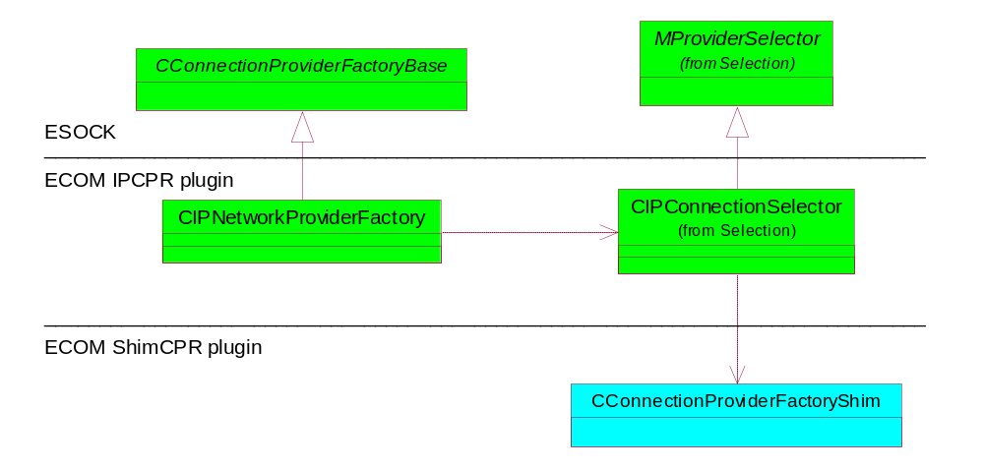
Figure 5-4 IPCPR Factory

IPCPR provider selection
The IPCPR provider selection depends at the directly on existence ShimCPR provider factory since it uses it to select and start the next layer provider. The IPCPR doesn’t provide its own selection as yet. The bellow picture shows the dependencies.
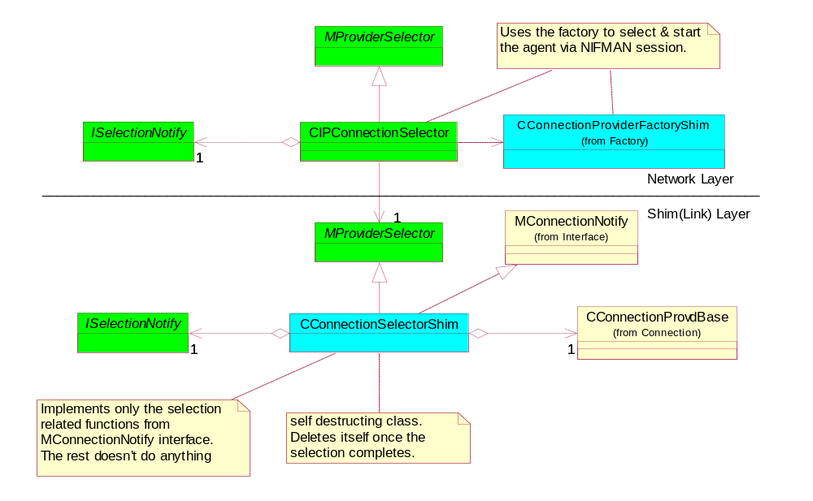
Figure 5-5 IPCPR selector dependencies on ShimCPR selector

IPSCPR ECom Plug-in
This section provides a useful summary of the IP sub-connection Provider (IPSCPR) ECom plugin. The plug-in builds on the ESOCK sub-connection framework and supplies primary(default) and secondary context IP sub-connections providers.

IP SubConnection Provider (CIPSubConnectionProvider/CDefaultSubConnectionProvider)
This plug-in is based on CSubConnectionProviderBase and implements MConnectionDataClient. CIPSubConnectionProvider represents secondary context and talks to the QoS framework via internal sockets. CDefaultSubConnectionProvider is pass through class providing minimal functionality mainly passing notifications from connection provider to its clients. The CDefaultSubConnectionProvider class is created for primary context.
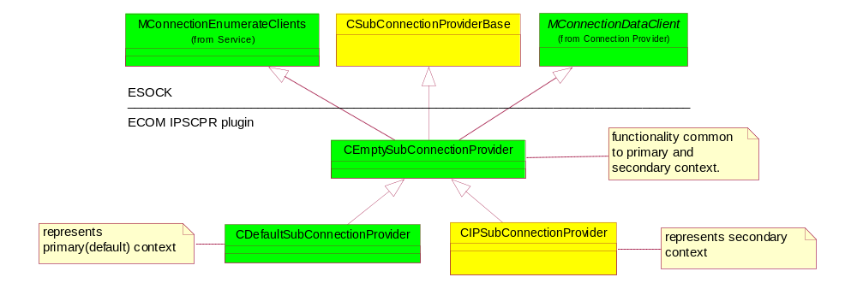
Figure 5-6 IPSCPR sub-connection provider class layout

IP SubConnection Provider Factory (CIpSubConnectionProviderFactory)
This is much simpler than the connection provider factory and has overwritten only one public method DoCreateProviderL(). It is based on CSubConnectionProviderFactoryBase.

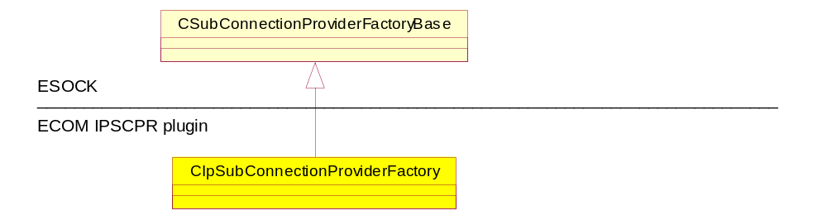
Figure 5-7 IPSCPR factory

ShimCPR ECom plug-in
The plug-in shields NIFMAN posing as a “hard-coded” at the moment mandatory link layer for IP address family and the IPCPR directly depends on in. It effectively replaces former CInterface functionality. It implements CConnectionProviderBase, CConnectionProviderFactoryBase and CConnectionSettings interfaces. It also implements MConnectionNotify interface to accommodate former CConnectionProvdBase the NIFMAN session is based on. The plug-in provides CConnectionSelectorShim selector class based on MProviderSelector. The selector implements MConnectionNotify interface and creates its own NIFMAN session to select and start agent and NIF.

Shim connection provider (CConnectionProviderShim)
The class implements CConnectionProviderBase and MConnectionNotify plus creates CconnectionSettingsShim instance to access connection settings. CConnectionSettingsShim can be obtained via SettingsAccessL() call.
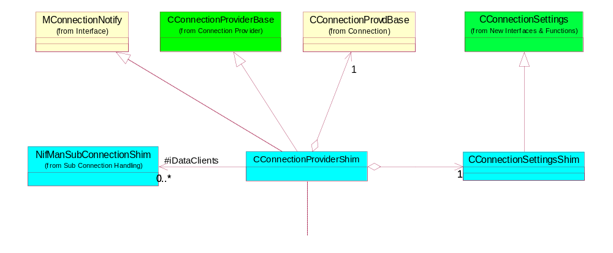
Figure 5-8 ShimCPR class layout
The Figure 5-8 shows a strong coupling between CConnectionProviderShim and NifManSubConnectionShim meaning that CConnectionProviderShim knows that each data client is in fact NifManSubConnectionShim . This coupling is intentional and simplifies the shim layer. The class owns an instance of CConnectionProvdBase that is in fact hard coded to be CNifSecureSession.

Shim Connection Provider Factory (CConnectionProviderFactoryShim)
The class is based on CConnectionProviderFactoryBase depends on CConnectionSelectorShim to start connection and owns its own CNifSecureSession to enumerate connections and register for all interface notification.
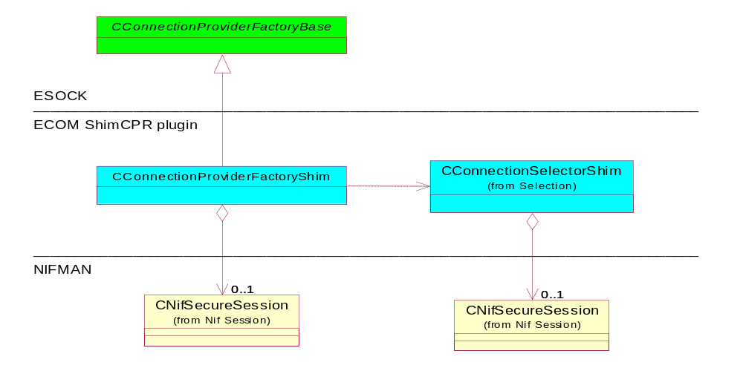
Figure 5-9 Shim Connection Provider factory class layout

Shim Connection Provider Selection (CConnectionProviderFactoryShim)
This is probably the trickiest part of the all design since it translates one selection logic (the NIFMANs one) into the other (the connection provider selection’s one). NIFMAN selects and starts link interface in one go as a response to CNifSecuresession::StartL call. Once the interface has been started it needs to be assigned an instance of CConnectionProviderShim that is either already existing one or a new one. The selector implements MConnectionNotify interface to forward events up via ISelectionNotify. The following scenarios can happen here:
- Selection succeeds – the CConnectionProviderShim instance is selected and ISelectionNotify::SelectComplete is called with the selected provider and the selector deletes itself. In case the shim provider instance has just been created the selector hands over the CNifSecureSession created for selection to it. The ISelectionNotify::SelectComplete call effectively hands over the ownership of the selected provider to whoever is waiting for the selection to complete. For that reason the CConnectionProviderShim is referenced object.
- Selection fails – ISelectionNotify::SelectComplete is called with NULL provider and error code. The selector than waits for the KConnectionUninitialised state to delete itself.
- Selection cancelled – if asked the selector stops connection than it always deletes itself and the CNifSecureSession object created for the selection.

The selector object deletes asynchronously so that the current active scheduler stack gets cleared.
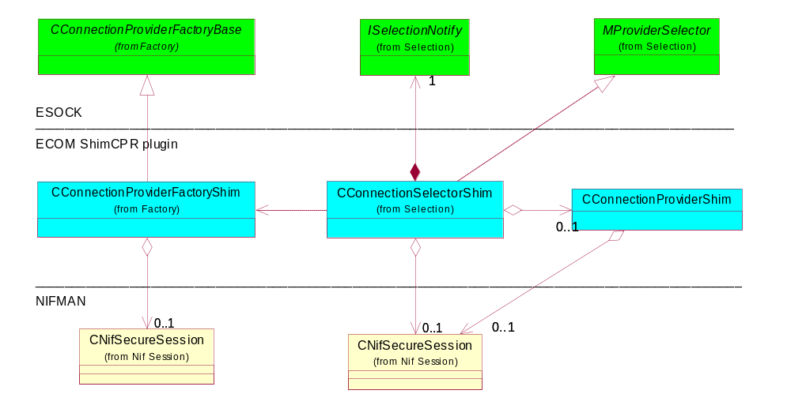
Figure 5-10 Shim Selector class layout

SubConnection monitoring - CNifManSubConnectionShim
The shim connection provider plug-in also replaces former CSubInterface,CSubConnection still following NIFMAN style (hence the name) subconnections. It also satisfies the RConnection preception of SubConnections. The plug-in implements NifManSubConnectionShim (representing the actual subconnection), CConnDataTransferShim and CSubConnectionLinkShimClient classes. The only way an instance of the NifManSubConnectionShim gets created is on CConnectionProviderShim::SubConnectionEvent(ESubConnectionOpened) up-call. The destruction is either on CConnectionProviderShim::SubConnectionEvent(ESubConnectionClosed) up-call or on NifManSubConnectionShim ::ConnectionGoingDown() notification.
API Name | Broad Purpose
NifManSubConnectionShim | Replaces CSubInterface providing a sub-connection related communication with CNifSecureSession
CConnDataTransferShim | Replaces that part of CSubInterface/CSubConnection pair that dealt with data monitoring requests.
CSubConnectionLinkShimClient | Replaces CSubConnection. It is created by NifManSubConnectionShim whenever CConnection joins CConnectionProviderShim instance and destroyed when CConnection leaves CConnectionProviderShim instance.
MShimControlClient | Interfaces seen by ESOCK and looked up by CSubConnectionProviderFactoryShim based on TSubConnectionUniqueId that receives all sub-connection related calls made via RConnection/CConnection.

The class worth detailed description here is the CSubConnectionLinkShimClient class. It implements MShimControlClient interface and receives all sub-connection related calls made via RConnection/CConnection.
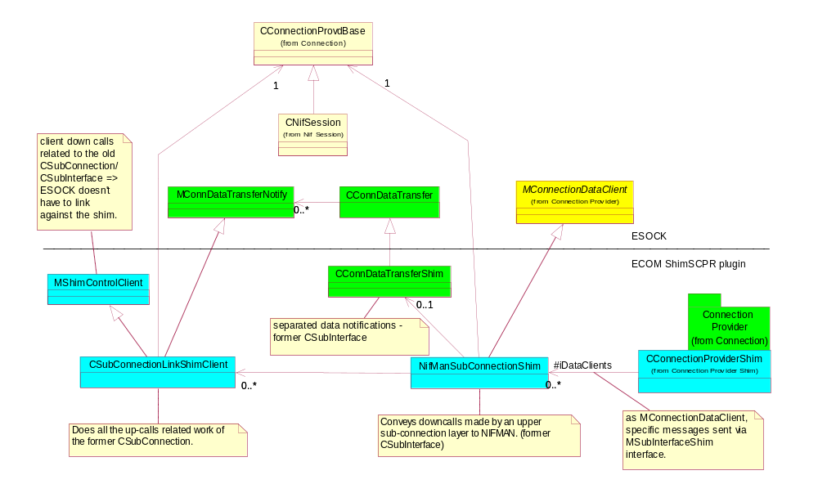 Figure 5-11 ShimCPR - subconnection handling class layout

Classes interoperability description
The following section briefly depicts the class interaction concepts missing from [R7]. See [R7] for the main sequence diagrams.

Factories’ queries
All factories queries performed by fn like FindProvider(),FindOrCreateProviderL() works with a query class based on MCommsFactoryQuery abstract class having one pure virtual method Match(). The method takes one parameter TFactoryObjectInfo instance describing XFactoryObject instance and can return one of the following:
- EMatch the match has been found
- EContinue give me another description
- ECancel cancel the search
The selected XFactoryObject instance is stored in TFactoryObjectInfo::iSelectedFactoryObject by an implementation the Match() function so that the search for the best match can be carried on.
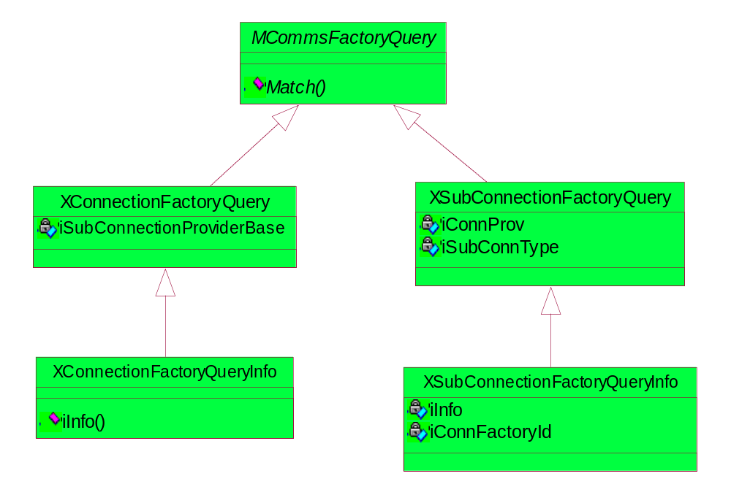
Figure 6-12 ESOCK implemented factories’ queries

Architectural Information

System Architectural Requirements
None

Binary Compatibility
This release is not BC with the previous releases. The following list summarises the changes:-
- EsockSvr.def file has been repopulated

Security
See 7.4.

Future considerations
It is envisioned that something like a default/implicit connection/sub-connection provider should exist to provide a minimal layer/protocol family agnostic functionality so that other providers don’t have to reinvent the wheel. It’s also envisioned that NIFMAN as the “hard” coded link layer connection/sub-connection provider will disappear and will be replaced by the “true” connection/sub-connection provider the default version of which shall be based on the shim layer and some of the agent/agent reference functionality. The bearer mobility work as well as some of the ongoing networking design revealed a need for some new concepts to be considered and prototyped:
- Cross-thread/process interfaces
- State machine with a possibility to intercept state transition and define state diagram in run-time. It might be possible to use some of the concepts introduced in [R8]
- Signalling framework. Could be based on the existing NetSubscribe element.
- Securing connection/sub-connection providers

The work also revealed a very fragile ESock MT timing issues and the complexity of the current approach related mainly to protocol loading and binding. There is a need to refractor the existing solution and compose it together from conceptual pieces rather than program it as a block consisting from locally optimised algorithms. Some of these conceptual pieces could be reused in the above mentioned prototypes.
The next step(s) in evolving the current solution would be:
- UMA network considerations – GSM signalling stack partially implemented as stackable data/control providers
- Management plane (see Table 1-1) plus policies
- Layering as metadata in CommDb so that the bottom layer represent physical AP (today’s IAP) e.g. access network and the top layer represents the final destination network.

Further Information

People
Role | Person / People
Contributor(s) | Richard Collin, Nadeem Wahid
Reviewer(s)

References
No. | Document |  | Version |  | Description
R1 | Bearer Mobility Proposal |  | 0.1 10-MAR-04 |  | This is the original outline by Drew Reed that sets out the main areas of work.
R2 |  | Esock Design Document |  | 1.06 | This document should be consulted with caution, as BM support makes significant changes to ESOCK.
R3 |  | Networking Architectural Description |  | 1.3 03-JUN-04 | Basic background.
R4 | Comms-Infras Subsystem Architectural Description |  | 2.4 |  | Very useful background.
R5 | NifMan Public API |  | 1.01 12-NOV-02 |  | BM support makes very little change to NIFMAN so these documents provide very useful background. (see R6).
R6 | NifMan Design Document |  | 1.1 SEP-03 |  | See R5 above.
R7 | PREQ 607 Definition |  | NA |  | This PREQ corresponds to a subset of the work needed to support bearer mobility.
R8 | E32RT_Design.doc |  | 2.02 03/10/2004 |  | EKA32 Real Time design
R7 | UML diagrams |  |  |  | Connection Stack (phase 1) UML

Open Issues
None

Abbreviations
The following technical terms and abbreviations are used within this document.
Term | Definition
BM | Bearer Mobility
CR | Change Request as per Symbian’s own definition
CPR | Connection Provider
SCPR | Sub-connection provider
MS | Mobility Server or Milestone, depending on context
NNF | Nokia Networking Factory
BC | Binary Compatibility
AP | Access Point
IAP | Internet Access Point

Document History
Date | Version | Status | Description
22-07-2005 | 0.3 | Draft | Updated to merge ShimSCPR into ShimCPR
10-03-2005 | 0.2 | Draft | Updated to capture most recent design changes
25-01-2005 | 0.1 | Draft | Created from various existing BM-related documents.

